CHAPTER ONE:

INTRODUCTION

1 **Background of the Study**

Breast cancer continues to be the most frequently diagnosed malignancy among women and ranks as a primary cause of cancer-related mortality globally. It is responsible for approximately 24.5% of all cancer cases in females and accounts for 15.5% of cancer-related deaths1. Invasive ductal carcinoma of no special type (IDC NST) accounts for approximately 70-80% of all breast cancer cases2. The prognosis of invasive ductal carcinoma of no special type (IDC NST) exhibits considerable variability based on multiple histopathological and molecular markers. This underscores the need for further research to identify reliable prognostic indicators3.

Programmed death-ligand 1 (PD-L1) is an immune checkpoint protein that is integral to the process of tumor immune evasion4. Research shows that PD-L1 is found in about 20-50% of breast cancer cases, with a greater occurrence in triple-negative breast cancer (TNBC)5. Programmed Death-Ligand 1 (PD-L1) engages with Programmed Death-1 (PD-1) receptors on T-cells, thereby inhibiting immune responses and enabling tumor cells to evade immune surveillance 6. Numerous studies have investigated the expression of PD-L1 in breast cancer, particularly its significance in predicting responses to immunotherapy and its potential utility as a prognostic marker7.

Studies reported that elevated levels of PD-L1 expression were identified in 51.7% of cases of invasive ductal carcinoma4,7,8. This significantly correlated with various factors, including high tumor grade, lymphovascular invasion, infiltrated tumor margins, lymph node metastasis, estrogen receptor-negative status, progesterone receptor-negative status, and increased Ki-67 expression7. Several studies identified a significant correlation between PD-L1 expressions in tumor cells and tumor-infiltrating lymphocytes (TILs) with the Ki-67 index, hormone receptor status, and the aggressiveness of the tumor8.

Despite the growing body of research on PD-L1 expression in breast cancer, there exists a notable degree of conflicting data concerning its prognostic significance3. Certain research indicates that PD-L1 expression is associated with more aggressive tumor features, while other studies suggest it may contribute to improved outcomes due to a stronger immune response 4,7,8. Considering these discrepancies, it is essential to conduct further investigation, particularly within the Nigerian population, where data remains scarce1. Figure 1 presents a graphical summary of global breast cancer incidence and PD-L1 expression patterns.

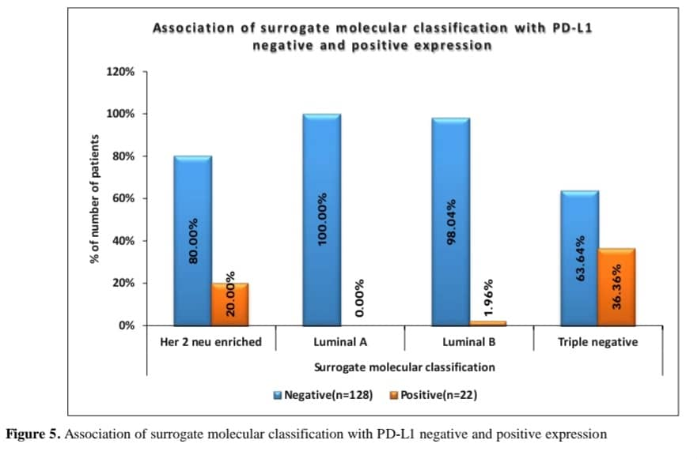

2. **Problem Statement**

Breast cancer in Nigeria remains a significant health challenge, with many cases diagnosed at advanced stages, contributing to a mortality rate exceeding 40% 1. Although PD-L1 expression has been extensively studied in Western and Asian populations, data from African cohorts, including Nigeria, are scarce 6. The prognostic significance of PD-L1 in IDC NST in the Nigerian population is unclear. Understanding the correlation between PD-L1 expression and clinicopathological features may aid in better prognostication and targeted therapeutic strategies 2. Figure 2 illustrates the percentage of PD-L1 positivity across different breast cancer subtypes.

3 **Justification of the Study**

The assessment of PD-L1 expression in IDC NST is essential for advancing personalized medicine in Nigeria 5. Given the increasing role of immune checkpoint inhibitors in cancer treatment, understanding PD-L1's expression pattern and prognostic implications in Nigerian breast cancer patients is crucial 4. reported that PD-L1-positive TNBCs exhibited higher tumor-infiltrating lymphocytes and increased expression of antigen-presenting proteins, potentially influencing immune therapy outcomes 9. This study will provide valuable data that could inform future clinical trials and therapeutic guidelines 3.

4 **Research Questions**

What is the prevalence of PD-L1 expression in IDC NST in patients at Federal Teaching Hospital, Gombe?

How does PD-L1 expression correlate with prognostic parameters such as tumor grade, lymph node involvement, hormone receptor status, and Ki-67 proliferation index?

What is the potential prognostic significance of PD-L1 expression in IDC NST patients in Nigeria?

5 **General Objective**

To determine the immunohistochemical expression of PD-L1 in IDC NST in Federal Teaching Hospital, Gombe, and its correlation with prognostic parameters

6 **Specific Objectives**

1) To evaluate the prevalence of PD-L1 expression in IDC NST using immunohistochemistry

2) To analyze the correlation between PD-L1 expression and key prognostic parameters, including tumor grade, lymph node metastasis, and hormone receptor status.

3) To assess the potential prognostic implications of PD-L1 expression in IDC NST.

7 **Scope of Study**

This study will be conducted at Federal Teaching Hospital, Gombe, involving patients diagnosed with IDC NST between January 2022 and December 2024. Histopathological samples will be retrieved, and immunohistochemistry will be performed to assess PD-L1 expression. Clinicopathological data, including age, tumor size, grade, receptor status, and follow-up information, will be analyzed.

7 **Significance of the Study**

The conclusions drawn from this research could significantly enhance clinical decision-making concerning the management of Invasive Ductal Carcinoma, No Special Type (IDC NST) among Nigerian patients. 1. By clarifying the role of Programmed Death-Ligand 1 (PD-L1) in prognosis, this study may facilitate the development of future clinical trials focused on immunotherapeutic approaches in Nigeria. 2. Furthermore, it will enrich the global knowledge base regarding PD-L1 expression in breast cancer and its prognostic implications. 3.

**References**

1 Punhanni P, Ahluwalia C. Expression of PD-L1 in Breast Cancer and Its Correlation with Prognostic Parameters. Arch Breast Cancer. 2023;10(3):280-290.

2 Abdelrahman DI, Assaf MI, Rashed HE, Ibrahim DA, Abdelhamed MI. Immunohistochemical Expression of PD-L1 in Invasive Ductal Carcinoma NST. Zagazig Univ Med J. 2019;26(6):928-932.

2 Zhou T, Xu D, Tang B, Ren Y, Han Y, Liang G, et al. Expression of PD-L1 and Its Correlation with Prognostic Parameters in Breast Cancer. Anti-Cancer Drugs. 2018;29(10):904-910.

3 Sharma R, Elhence PA, Rao M, et al. Crosstalk Between PD-L1, Ki-67 Labelling Index, and Tumor-Infiltrating Lymphocytes in Breast Cancer. Iran J Pathol. 2022;17(3):314-322.

3 Carter JM, Polley MY, Leon-Ferre RA, et al. Characteristics and Spatially Defined Immune (Micro)Landscapes of Early-stage PD-L1–Positive Triple-Negative Breast Cancer. Clin Cancer Res. 2021;27(20):5628-5637.

3 Reda NM, Abd El Gaber NA, Mohammedan MA, Mohammed ON. Immunohistochemical Expression of PD-L1 in Invasive Ductal Carcinoma of the Breast. Minia J Med Res. 2020;31(2):122-127.

4 Reddy OL, Shintaku PI, Moatamed NA. Programmed Death-Ligand 1 (PD-L1) Expression in Cervical Carcinomas. Diagn Pathol. 2017;12(1):45

5 Carter JM, et al. PD-L1 Expression in Triple-Negative Breast Cancer. Clin Cancer Res. 2021;27(20):5628-5637.

6 Sharma R, et al. Immune Microenvironments in Breast Cancer. Iran J Pathol. 2022;17(3):314-322.

7 Lou J, et al. PD-L1 and Breast Cancer Prognostic Factors. Open Med. 2017;12:288-292.